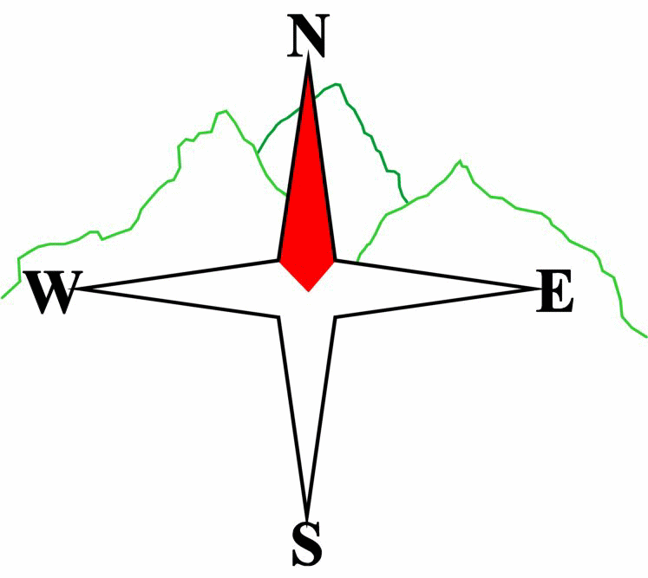***Blairgowrie & District Hillwalking Club***

**Web site: www.bdhc.org.uk**

West Ochils

**Map 58**

18th February 2024

|  |  |  |  |  |
| --- | --- | --- | --- | --- |
| **Bus start:** | **Blairgowrie** (**Wellmeadow**): **09.00 am** | | **Alyth** (**Square**): **08.45 am** | |
|  | | | | |
| A Walk – Blairdenon Hill (Donald) | | | | |
| From Main St, Menstrie go up Park Rd. Turn right into Ochil Rd. After 100 m take track on left that zigzags up the hillside. After approx. 2.5km, cross the First Inchna Burn and follow an ATV track up the SW spur of Colsnaur Hill (553m). Head N beside a drystane dyke and fence over Menstrie Moss to Blairdenon Hill (631m). Head E then SE to pick up the top of the track at NS889010 then head S to The Nebit (449m). Return to track and descend to Alva. | | | | |
| Approx. distance: 16.1 km | | Total ascent: 843 m | | Min. **walking** time: 5½ hrs |
|  | | | | |
| B Walk – Blairdenon Hill and Bengengie Hill | | | | |
| As A walk to Blairdenon Hill (631m) then S to Bengengie Hill. Head E for 0.5km to pick up the top of the track at NS873004, before descending on the track to Alva. | | | | |
| Approx. distance: 15.3 km | | Total ascent: 650 m | | Min. **walking** time: 4¾ hrs |
|  | | | | |
| C Walk – Lower Alva Glen and Ochils Hills Woodland Park | | | | |
| Starting in Alva head N up Alva Glen past Alva Dam and Smugglers Cave to Spout of Craighorn. Return via the high path on the W of the Glen (the Pate Road). From the carpark, follow tracks and paths eastwards to Silver Glen and Ochil Hills Woodland Park. There is a choice of walks here. Return to rendezvous point in Alva. Some information leaflets will be available on the day or for more info: <https://www.clacks.gov.uk/site/documents/countryside/ochilhillswoodlandparkalvaleaflet/> | | | | |
| Approx. distance: 8 km | | Total ascent: 340m | | Min. **walking** time: 4 hrs |

|  |  |
| --- | --- |
| IMPORTANT: YOUR SAFETY IN THE HILLS | |
| **The Committee reminds members and guests of the following important points:** | |
| * You are responsible for your own safety * Club officials are not trained mountain leaders * Are you fit enough to complete your chosen walk in the available time? * Know where you are going on the walk and follow the route on your map. * Know how many are in your party and stay together | * Ensure you have enough food plus emergency rations * Carry a map & compass, survival bag, torch, whistle and small first aid kit. Know how to use them. * In winter conditions you must carry an ice axe on high level walks (club rule). You are also recommended to carry crampons. * **Learn** how to use your equipment. |
|
|
|
|
|  |
| **Club officials will be happy to give advice on any of these points if requested.** | |

**Please note that the Minimum walking times are based on reasonably fast walkers and assuming good conditions. The times do not include stops or breaks.**

## **In poor weather conditions or if members are not comfortable walking at 4km/hour then alternative or shorter routes should be considered.**

## The next club walk is on the 3rd March 2024 to Amulree starting at 08.00 am (Blairgowrie) and 07.45 am (Alyth).

Other information/events: Mountain Mind Quiz 12th March in Blairgowrie Golf Club