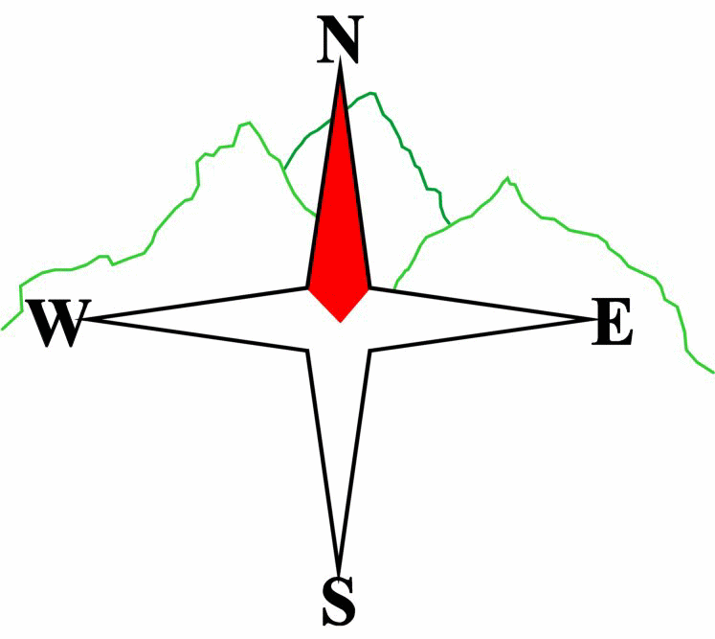***Blairgowrie & District Hillwalking Club***

**www.bdhc.org.uk**

**Bynack More**

**11/08/2024**

**O.S. Map No**: 36

|  |  |  |  |  |
| --- | --- | --- | --- | --- |
| **Bus times:** | **Blairgowrie** (**Wellmeadow**): **07:30** | | **Alyth** (**Square**): **07:15** | |
|  | **Other - Birnam : 07:50** | | | |
| - | | | | |
| A Walk – Bynack More | | | | |
| Start at the Coire na Ciste car park NH 998 074, head east, cross the burn and pick up a rough path heading NE towards Lochan na Beinne, pass this to the S and climb to the col on the NW of point 737. Head steeply down into Strath Nethy, cross the river onto the NW shoulder of Bynack Beg. Continue SE to the summit of Bynack More (**M**) 1090m. From the summit head N and pick up the well-worn path & steps down towards Bynack Stable and beyond, turning left at the path junction, Follow this path past An Lochan Uaine to meet the coach at the public car park near to the Reindeer Centre. | | | | |
| Approx. distance: 17.4 km | | Total ascent: 880 m | | Min. **walking** time: 5 ¾ hrs |
|  | | | | |
| B Walk – Meall a Bhuachaille via Craiggowrie | | | | |
| Start at the car park close to the Reindeer Centre NH 975 098 Cross the road and take the track heading NW to the holiday park at Badaguish. Take the northerly path to 949 127. From there head NE to Craiggowrie. From the summit follow the ridge path to Meall a Bhuachaille (**C**) 810m, passing over Creagan Gorm on the way. Follow the path E to the Ryvoan bothy, turn right onto the track and follow past An Lochan Uaine back to the car park and waiting coach. | | | | |
| Approx. distance: 17 km | | Total ascent: 734 m | | Min. **walking** time: 5 ½ hrs |
|  | | | | |
| C Walk – An Lochan Uaine (The Green Lochan) | | | | |
| Start as B walk. Follow the road to Glenmore Lodge and continue on the good track to An Lochan Uaine. This is a wonderful picnic site and the adventurous might try wild swimming. Continue to Ryvoan bothy. On return from An Lochan take the path through the woods which after about 1km meets a forest track to be followed downhill to the start. There are other walks from Glenmore to extend the day. | | | | |
| Approx. distance: 8 km | | Total ascent: 170 m | | Min. **walking** time: 3 hrs (@ 3 kph) |

**Please note that the Minimum walking times are based on reasonably fast walkers and assuming good conditions. The times do not include stops or breaks.**

## **In poor weather conditions or if members are not comfortable walking at 4km/hour then alternative or shorter routes should be considered.**

The next club walk is on the **01/09/2024** to Glen Dochart starting at 07:30 Wellmeadow, Blairgowrie, 07:15 Alyth.

Other information/events: BBQ  **26th August** further info TBA. Slide Night **13th Sept**.

Autumn weekend **20/22 September,** Kelso.

|  |  |
| --- | --- |
| IMPORTANT: YOUR SAFETY IN THE HILLS | |
| **The Committee reminds members and guests of the following important points:** | |
| * You are responsible for your own safety * Club officials are not trained mountain leaders * Are you fit enough to complete your chosen walk in the available time? * Know where you are going on the walk and follow the route on your map. * Know how many are in your party and stay together | * Ensure you have enough food plus emergency rations * Carry a map & compass, survival bag, torch, whistle and small first aid kit. Know how to use them. * In winter conditions you must carry an ice axe on high level walks (club rule). You are also recommended to carry crampons. * **Learn** how to use your equipment. |
|
|
|
|
|  |
| **Club officials will be happy to give advice on any of these points if requested.** | |