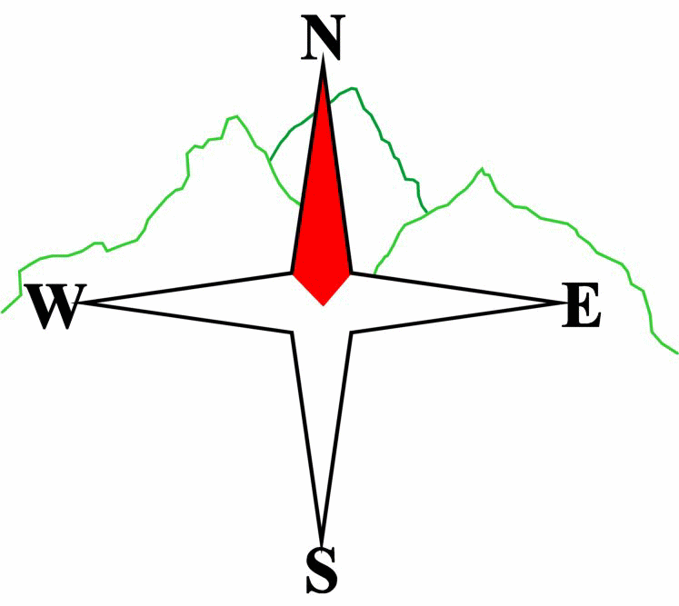***Blairgowrie & District Hillwalking Club***

**www.bdhc.org.uk**

**Inverey**

**13/10/2024**

**O.S. Map No**: 43

|  |  |  |  |  |
| --- | --- | --- | --- | --- |
| **Bus times:** | **Blairgowrie** (**Wellmeadow**): **08:00** | | **Alyth** (**Square**): **07:45** | |
|  |  | | | |
|  | | | | |
| A Walk – Carn Bhac | | | | |
| Start Inverey carpark NO 089 892. Take track S up Glen Ey to junction at Auchellie. Ascend track W then SW over Carn nan Seileach continuing along the ridge to Carn Creagach (894m). Descend W to bealach and then climb to the summit of **Carn Bhac (M 946m)**. Descend SW to point 920m then turn N down ridge which, veering E, leads to Carn Damhaireach or Top of the Battery (784m). Descend NE ridge to glen and track which continues NE then N back to Inverey. | | | | |
| Approx. distance: 20 km | | Total ascent: 840 m | | Min. **walking** time: 6½ hrs |
|  | | | | |
| B Walk – Carn Liath | | | | |
| Start as A walk. Take road W across bridge then immediately turn left on track going S. Continue as it turns SW then W to ascend to the bealach where it turns N to summit of **Carn Liath (818m)**. Descend ENE along ridge over Carn na Moine (755m) and into forest where track turns N to return to road . Turn E to get to carpark. | | | | |
| Approx. distance: 16 km | | Total ascent: 550 m | | Min. **walking** time: 5 hrs |
|  | | | | |
| C Walk – Creag Choinnich circular, Braemar | | | | |
| Start visitor centre, Braemar, NO 150 914. Walk E across the bridge. Cross A93 and take waymarked path for **Creag Choinnich (538m)**. This is a steep but short ascent. Return by same route to the junction for the circular path at approx. 157 914. Go N to follow this path in a clockwise direction round Creag Choinnich until reaching a disused quarry. From here take a track SE then W rising below the Lion’s Face. Continue on this track until reaching the A93. Go N 200m, cross the road and take path W to the river and a footbridge at 150 910. Walk N back to start on quiet public road. | | | | |
| Approx. distance: 10 km | | Total ascent: 400 m | | Min. **walking** time: 4 hrs (@3kph) |

**Please note that the Minimum walking times are based on reasonably fast walkers and assuming good conditions. The times do not include stops or breaks.**

## **In poor weather conditions or if members are not comfortable walking at 4km/hour then alternative or shorter routes should be considered.**

The next club walk is on the **03/11/2024** to Farragon Hill starting at 08:00 am (Blairgowrie) and 07:45 am (Alyth).

Other information/events: **Club night – Golf Course 25/10/24**

|  |  |
| --- | --- |
| IMPORTANT: YOUR SAFETY IN THE HILLS | |
| **The Committee reminds members and guests of the following important points:** | |
| * You are responsible for your own safety * Club officials are not trained mountain leaders * Are you fit enough to complete your chosen walk in the available time? * Know where you are going on the walk and follow the route on your map. * Know how many are in your party and stay together | * Ensure you have enough food plus emergency rations * Carry a map & compass, survival bag, torch, whistle and small first aid kit. Know how to use them. * In winter conditions you must carry an ice axe on high level walks (club rule). You are also recommended to carry crampons. * **Learn** how to use your equipment. |
|
|
|
|
|  |
| **Club officials will be happy to give advice on any of these points if requested.** | |