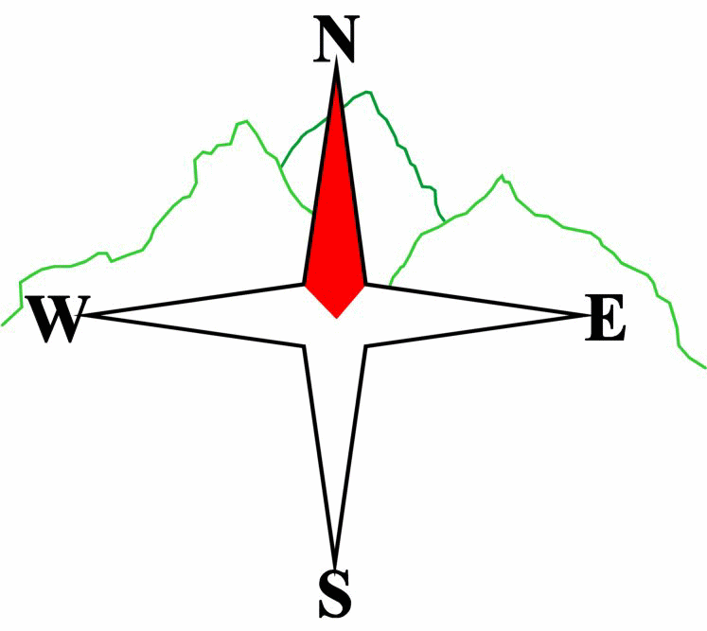***Blairgowrie & District Hillwalking Club***

**www.bdhc.org.uk**

**SIDLAWS – Northballo Hill to Newtyle**

**05/01/2025**

**O.S. Map No**: **53**

|  |  |  |  |  |
| --- | --- | --- | --- | --- |
| **Meeting times:** | **Blairgowrie** (**Wellmeadow**): **9:00 am** | | **Alyth** (**Square**): **8:45 am** | |
|  |  | | | |
| **Transport:** | **COACH** | | | |
|  | | | | |
| All Walks – Northballo Hill to Newtyle | | | | |
| Start at NO 250 349 Car park on SW side of Northballo Hill. Head up the zigzag path and turn left when you reach the wider forestry track (heading west) (You can reduce the distance by 1km if you go right to Lairds Loch). Follow the track round the hill to junction at 254 357, take left descending track then after about 350m turn sharp right and follow the track to the dam at Lairds Loch.  At Lairds Loch, cross the dam and turn right to follow the path east to the Tullbaccart car park (264 360)  Cross the A923 and follow the track through Tullibaccart farm N then NE towards Pitcur Wood and Ledcrieff Loch.  Take the left track and follow this around through the woodlands ignoring any branches/turns until you reach a junction at 277 378. Turn E and exit the forestry at 279 379. Follow track to aerial then east to the trig point summit of Lundie Crags.  An alternative, slightly shorter but more rugged route is to head along the SE side of Ledcrieff Loch and ascend the crags after the forestry and follow the path on the edge of the crags to the top.  From the top head back to the track then approximately north to reach the 332m spot height at 281 385. Pick up hill track heading NE (near fence) to go past the monument. At 289 395 turn left (near a boundary wall/fence from the NW) follow the hill track NW down to a gate gap in the wall (286 399). Head along the grassy track NE through a short section of woodland and through a gate into a field, follow the left edge of the field, then head east over the railway bridge and through the field (right of way) to Bannatyne house. Take Kirkton Road to the main road. Turn right then first left (Belmont Street), at the end turn right to the Commercial Hotel for refreshments.  Note: Final part can be extended by dropping onto the railway line walk from the east end of the railway bridge and following the route round to return by the end of the Water Backie (not named on OS map). A longer route is along the Water Backie to Ralston, across the main road to the old railway and then South along the railway to Newtyle. | | | | |
| Approx. distance: 13.4 km | | Total ascent: 305 m | | Min. **walking** time: 4 hrs |
|  | | | | |
|  | |  | |  |

**Please note that the Minimum walking times are based on reasonably fast walkers and assuming good conditions. The times do not include stops or breaks.**

## **In poor weather conditions or if members are not comfortable walking at 4km/hour then alternative or shorter routes should be considered.**

Template revision: 2024-12-03

The next club walk is on the **26/01/2025** to the Pentlands starting at 08:30 am (Blairgowrie) and 08:15 am (Alyth).

Other information/events: **Annual Quiz Night** on **07/02/2025** at the Blairgowrie Golf Club **19:00 for 19:30.**

|  |  |
| --- | --- |
| IMPORTANT: YOUR SAFETY IN THE HILLS | |
| **The Committee reminds members and guests of the following important points:** | |
| * You are responsible for your own safety * Club officials are not trained mountain leaders * Are you fit enough to complete your chosen walk in the available time? * Know where you are going on the walk and follow the route on your map. * Know how many are in your party and stay together | * Ensure you have enough food plus emergency rations * Carry a map & compass, survival bag, torch, whistle and small first aid kit. Know how to use them. * In winter conditions you must carry an ice axe on high level walks (club rule). You are also recommended to carry crampons. * **Learn** how to use your equipment. |
|
|
|
|
|  |
| **Club officials will be happy to give advice on any of these points if requested.** | |