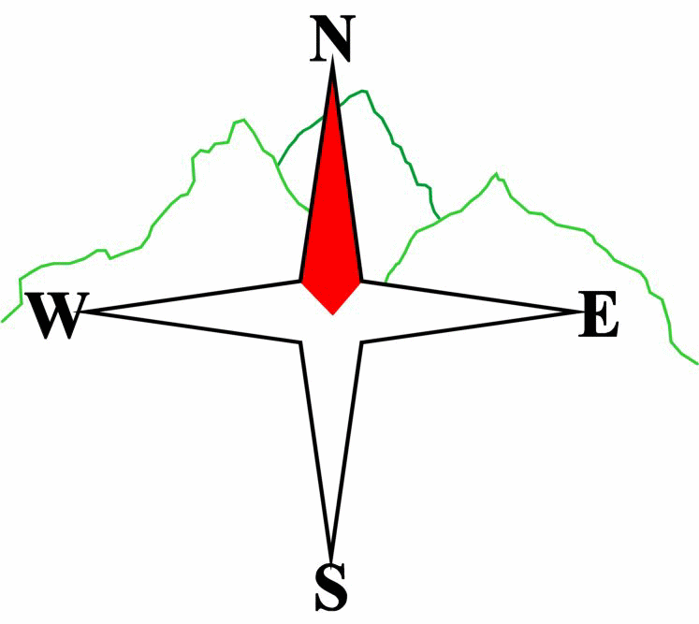
Blairgowrie & District Hillwalking Club

www.bdhc.org.uk
Pentland Hills

26 January 2025
O.S. Map No: 66

Meeting : | Blairgowrie (Wellmeadow): 8.30 am |  | Alyth (Square): 8.15 am
times : | Broxden Park and Ride 9:00 am
Transport: | COACH

NB Names with * are not on 1:50 OS map.

A Walk – Carnethy Hill, Scald Law, East Kip and West Kip
Start Harlaw Farm (NT 179 657). Walk SE past carpark then E to Maiden’s Cleugh* (valley between Harbour Hill and Bell’s Hill). Continue on path to Glencorse Reservoir turn right and go SW on minor road. Take bridge opposite Logan House (204 630), climb SSE to col at 208 623 then climb SW to Carnethy Hill (573m). Continue westward over Scald Law (579m), East Kip(534m) and West Kip (551m). Descend from West Kip summit via a faint path in a northerly direction to Logan Burn. Cross and ascend to meet path (not shown on map) at 177 617. Follow NE then N through Green Cleugh* to E end of Threipmuir reservoir. Cross. Turn immediately E then NNW after 200 m to pick up paths and tracks returning to start.

Approx. distance: 17 km |  | Total ascent: 830 m |  | Min. walking time: 5 ½ hrs

B Walk – Bell’s Hill from Maiden’s Cleugh*
As A walk to Maiden’s Cleugh*, after climbing over style at 203 649, leave the through path and head S on a path ascending Bell’s Hill (406m), return the same way to rejoin main path. Continue SE to meet minor road at Glencorse reservoir. Turn right and continue SW past Loganlea reservoir and The Howe before turning NW through Green Cleugh* to meet the path on the north side of Black Hill going to Threipmuir reservoir, the dam and the Harlaw Visitor centre. Return to start.

Approx. 16 km |  | Total ascent: 460 m |  | Min walking time: 4 ¾ hrs

C Walk – Harlaw and Threipmuir reservoirs
Start as A and B but turn S after carpark to Harlaw visitor centre. Head SW to Threipmuir reservoir. Continue on N side to Redford wood* and Red Moss* nature reserve (board walk). Go southwards over Redford Bridge* past Bavelaw Castle (occupied) to a path junction at 179 625. Go northwards to E end of Threipmuir Reservoir. Cross. Turn W to follow lochside until crossing the dam then go NNE to return to visitor centre and return to start.

Approx. distance: 12 km |  | Total ascent: 260 m |  | Min. walking time: 4 ½ hrs (@ 3 kph)
Please note that the Minimum walking times are based on reasonably fast walkers and assuming good conditions. The times do not include stops or breaks.

In poor weather conditions or if members are not comfortable walking at 4km/hour then alternative or shorter routes should be considered.

Template revision: 2024-12-03

IMPORTANT: YOUR SAFETY IN THE HILLS
The Committee reminds members and guests of the following important points:
- You are responsible for your own safety  - Club officials are not trained mountain leaders  - Are you fit enough to complete your chosen walk in the available time?  - Know where you are going on the walk and follow the route on your map.  - Know how many are in your party and stay together | - Ensure you have enough food plus emergency rations  - Carry a map & compass, survival bag, torch, whistle and small first aid kit. Know how to use them.  - In winter conditions you must carry an ice axe on high level walks (club rule). You are also recommended to carry crampons.  - Learn how to use your equipment.
Club officials will be happy to give advice on any of these points if requested.

The next club walk is on 16/02/2025 to west Drumochter starting at 0800 am (Blairgowrie) and 07.45 am (Alyth).
Other information/events: Quiz night Blairgowrie Golf club 19.30 7 February 2025

