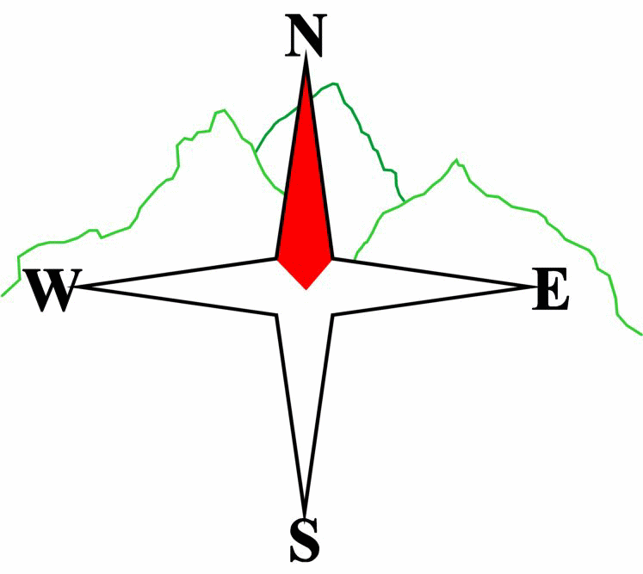***Blairgowrie & District Hillwalking Club***

**www.bdhc.org.uk**

**Ben Lomond / Loch Lomond**

**20/04/2025**

**O.S. Map No**: **56 (or OL 39)**

|  |  |  |  |  |
| --- | --- | --- | --- | --- |
| **Meeting :** | **Blairgowrie** (**Wellmeadow**): **7:30 am** | | **Alyth** (**Square**): **7:15 am** | |
| **times :** | **Other: Perth (Broxden P&R): 7:50 am** | | | |
| **Transport:** | **CARS** | | | |
|  | | | | |
| A (& B) Walk – Ben Lomond | | | | |
| Start carpark NS 359 986. Walk north from carpark (West Highland Way) for about 900m, take path to right at 360 994 to head NE then N on west flank of lower ridge passing Tom Fithich (499m) before ascending to the main Ptarmigan ridge. Follow the ridge (N then NE) to the col at 362 029 then ascend the NW ridge to the summit of **Ben Lomond M 974 m**. Descend SE then S by "tourist" path via Sròn Aonaich (577m) and then SW through forest to the car park. | | | | |
| Approx. distance: 12 km | | Total ascent: 1060 m | | Min. **walking** time: 4 ¾ hrs |
|  | | | | |
|  | | | | |
|  | | | | |
|  | |  | |  |
|  | | | | |
| C Walk – Balmaha to Rowardennan | | | | |
| Start carpark at Balmaha NS 421 909 and follow the WHW north as it makes its way along the edge of Loch Lomond through a series of woods, water edges and open areas/viewpoints to Rowardennan car park.  Car transport back to Balmaha with A walkers can be organised on the day. | | | | |
| Approx. distance: 13 km | | Total ascent: 350 m | | Min. **walking** time: 5 hrs (@ 3 kph) |

Template revision: 2024-12-03

The next club walk is on the **08/06/2025 to Upper Glencoe**.

Other information/events: **16-19 May. Weekend to Rum**.

**Please note that the Minimum walking times are based on reasonably fast walkers and assuming good conditions. The times do not include stops or breaks.**

## **In poor weather conditions or if members are not comfortable walking at 4km/hour then alternative or shorter routes should be considered.**

|  |  |
| --- | --- |
| IMPORTANT: YOUR SAFETY IN THE HILLS | |
| **The Committee reminds members and guests of the following important points:** | |
| * You are responsible for your own safety * Club officials are not trained mountain leaders * Are you fit enough to complete your chosen walk in the available time? * Know where you are going on the walk and follow the route on your map. * Know how many are in your party and stay together | * Ensure you have enough food plus emergency rations * Carry a map & compass, survival bag, torch, whistle and small first aid kit. Know how to use them. * In winter conditions you must carry an ice axe on high level walks (club rule). You are also recommended to carry crampons. * **Learn** how to use your equipment. |
|
|
|
|
|  |
| **Club officials will be happy to give advice on any of these points if requested.** | |