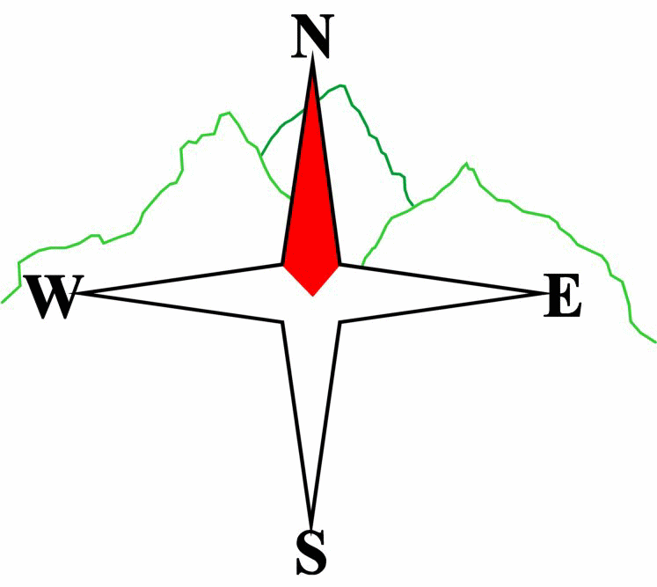***Blairgowrie & District Hillwalking Club***

**www.bdhc.org.uk**

**Black Mount – from Glencoe Mountain Resort**

**08/06/2025**

**O.S. Map No**: 41 & 50

|  |  |  |  |  |
| --- | --- | --- | --- | --- |
| **Bus times:** | **Blairgowrie** (**Wellmeadow**): **07:30** | | **Alyth** (**Square**): **07:15** | |
|  | **Other: Perth,** Broxden P&R: **08:00** | | | |
|  | | | | |
| A Walk – Meall a Bhuiridh & Creise | | | | |
| Start Glencoe Ski carpark NN 266 525. Take path beneath ski lift S to top of lift. Go W c.600m to bealach 254 517. Climb ridge S to summit of **Meall a Bhuiridh (M 1108m)**. Continue WSW down ridge to narrow bealach. Climb W to top of ridge. Go N c.700m to summit of **Creise (M 1100m)**. Return S but continue on to Clach Leathad (1099). Descend ESE down Sron nam Forsair to WHW at Ba Bridge. Turn N and follow WHW back to start. | | | | |
| Approx. distance: 17.5 km | | Total ascent: 1260 m | | Min. **walking** time: 7 hrs |
|  | | | | |
| B Walk – Meall a Bhuiridh | | | | |
| Start Glencoe Ski carpark NN 266 525. Take path beneath ski lift S to top of lift. Go W c.600m to bealach 254 517. Climb ridge S to summit of **Meall a Bhuiridh (M 1108m)**. Descend E then SE to Creag an Fhirich (705m). Then descend NE then E to Ba Cottage and follow WHW to Blackrock cottage then S to start. | | | | |
| Approx. distance: 12 km | | Total ascent: 800 m | | Min. **walking** time: 4 ½ hrs |
|  | | | | |
| C Walk – Bridge of Orchy to Tyndrum | | | | |
|  | | | | |
| From Bridge of Orchy Hotel follow the West Highland Way S to Tyndrum. | | | | |
| Approx. distance: 11.5 km | | Total ascent: 250 m | | Min. **walking** time: 4 ½ hrs (@3kph) |

## The next club walk is on the **13th July to Ben More** starting at 7.30 am (Blairgowrie) and 7.15 am (Alyth).

The following walk will be on **Saturday (not Sunday) 2nd August** by bus and train from **Rannoch station to Kingshouse.**

Other information/events: **9th August BBQ at Roddy’s**. Further details TBA

**Please note that the Minimum walking times are based on reasonably fast walkers and assuming good conditions. The times do not include stops or breaks.**

## **In poor weather conditions or if members are not comfortable walking at 4km/hour then alternative or shorter routes should be considered.**

|  |  |
| --- | --- |
| IMPORTANT: YOUR SAFETY IN THE HILLS | |
| **The Committee reminds members and guests of the following important points:** | |
| * You are responsible for your own safety * Club officials are not trained mountain leaders * Are you fit enough to complete your chosen walk in the available time? * Know where you are going on the walk and follow the route on your map. * Know how many are in your party and stay together | * Ensure you have enough food plus emergency rations * Carry a map & compass, survival bag, torch, whistle and small first aid kit. Know how to use them. * In winter conditions you must carry an ice axe on high level walks (club rule). You are also recommended to carry crampons. * **Learn** how to use your equipment. |
|
|
|
|
|  |
| **Club officials will be happy to give advice on any of these points if requested.** | |