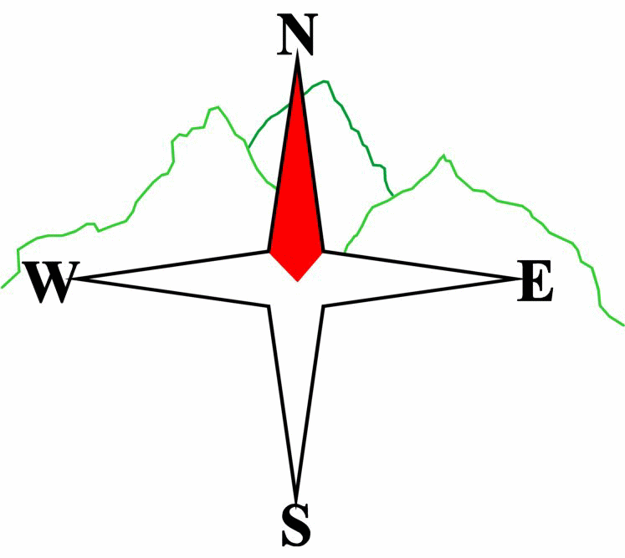***Blairgowrie & District Hillwalking Club***

**www.bdhc.org.uk**

**Glen Feshie**

**24/08/2025**

**O.S. Map No**: 35

|  |  |  |  |  |
| --- | --- | --- | --- | --- |
| **Meeting :** | **Blairgowrie** (**Wellmeadow**): **07.30 am** | | **Alyth** (**Square**): **07.15 am** | |
| **times :** | **Other: Dunkeld : 07.50 am** | | | |
| **Transport:** | **COACH** | | | |
|  | | | | |
| A Walk – Mullach Clach a’Bhlair & Carn Ban Mor | | | | |
| Start at car park before Auchlean in GlenFeshie (NN 851 985) and head S along E side of River Feshie past Carnachuin before ascending track up southern flank of Meall nan Sleac and on to Mullach Clach a’Bhlair (M=1019m). Descend to track and follow NE over 953m and on to Carn Ban Mor (1052m). From summit head W picking up track descending Coire Fhearnagan and back to Auchlean. | | | | |
| Approx. distance: 23 km | | Total ascent: 940 m | | Min. **walking** time: 7 ¼ hrs |
|  | | | | |
| B Walk – Mullach Clach a’Bhlair | | | | |
| As A walk to summit of Munro, Mullach Clach a’Bhlair then descend SW over Druim nam Bo to Lochan nam Bo. From here head W to pick up path which ascends Creag na Gaibhre, and descend to Ruigh-aiteachan bothy and follow track north up E side of River Feshie to Auchlean. | | | | |
| Approx. distance: 23 km | | Total ascent: 700 m | | Min. **walking** time: 7 hrs |
|  | | | | |
| C Walk – Speyside Way to Kingussie | | | | |
| Start at Loch Insh Watersports Centre (NN 840 044) and go eastwards on B970 to pick up Speyside Way at NN 842 045. Follow signposted trail bypassing Balnespick then into Inshriach Forest on tarmac road. At NN 838 022 the trail leaves the road to turn right looping around two lochans to the outskirts of Insh village. From there the trail goes SW to Inveruglas then on to Drumguish and Tromie Bridge. From here follow the B970 W sometimes on roadside path to Ruthven Barracks and Kingussie. | | | | |
| Approx. distance: 15 km | | Total ascent: 220 m | | Min. **walking** time: 5 ½ hrs (@3 kph) |

|  |  |
| --- | --- |
| IMPORTANT: YOUR SAFETY IN THE HILLS | |
| **The Committee reminds members and guests of the following important points:** | |
| * You are responsible for your own safety * Club officials are not trained mountain leaders * Are you fit enough to complete your chosen walk in the available time? * Know where you are going on the walk and follow the route on your map. * Know how many are in your party and stay together | * Ensure you have enough food plus emergency rations * Carry a map & compass, survival bag, torch, whistle and small first aid kit. Know how to use them. * In winter conditions you must carry an ice axe on high level walks (club rule). You are also recommended to carry crampons. * **Learn** how to use your equipment. |
|
|
|
|
|  |
| **Club officials will be happy to give advice on any of these points if requested.** | |

The next club walk is on the 19th-21st September (Beauly Weekend).

Other information/events: Club Slide Show & Calendar Night on 12th September.

**Please note that the Minimum walking times are based on reasonably fast walkers and assuming good conditions. The times do not include stops or breaks.**

## **In poor weather conditions or if members are not comfortable walking at 4km/hour then alternative or shorter routes should be considered.**

Template revision: 2024-12-03