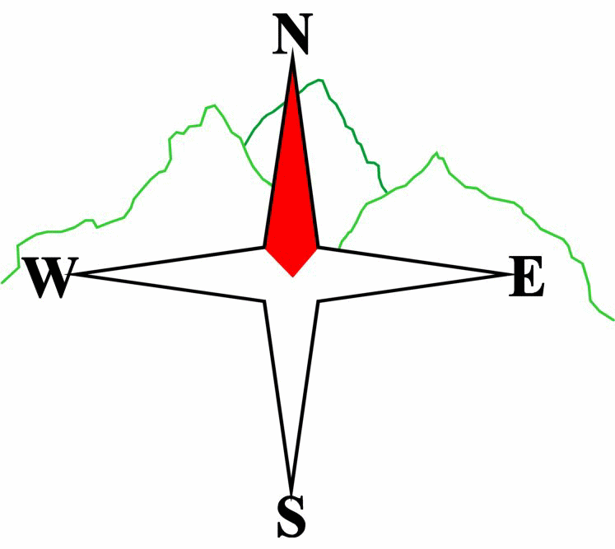***Blairgowrie & District Hillwalking Club***

**www.bdhc.org.uk**

**BEINN A GHLO / GLEN TILT / BLAIR ATHOLL**

**02/11/2025**

**O.S. Map No**: **43**

|  |  |  |  |  |
| --- | --- | --- | --- | --- |
| **Meeting :** | **Blairgowrie** (**Wellmeadow**): **8:00 am** | | **Alyth** (**Square**): **7:45 am** | |
| **times :** | **Other: Dunkeld: 8:20 am** | | | |
| **Transport:** | **COACH** | | | |
|  | | | | |
| A (and B) Walk – Carn Liath / Bràigh Coire Chruinn-bhalgain | | | | |
| Start from Loch Moraig car park along the farm track heading NE - continue through the gate. Follow track for about 1.5 km branch left at NN 923 678 past the "shed". Follow the track then branch onto the path across the boggy ground (stepping stones) and follow the made path to the summit of Carn Liath (‘grey peak’) (M-975m). Follow the ridge descending in a curve to Beinn Mhaol (possibly 'bald hill') then descend to the col (NN 939 714) (where B group descend east). Ascend from the col following the path first north then traverse east and finally north up the ridge to the summit of Bràigh Coire Chruinn-bhalgain ('The Upland of the Corrie of Round Lumps') (M-1070m).  Return by the ascent route to the Col and follow path (sometimes indistinct) east then south east beside the burn from the col then traverse to a broad col (just west of 678m spot height). Follow the track southwards to meet with the made path at approx NN 947 695. Continue south to join track (turn right), follow track west back to the car park and coach. | | | | |
| Approx. distance: 17.7 km | | Total ascent: 991 m | | Min. **walking** time: 6.25 hrs |
|  | | | | |
| B Walk – Carn Liath | | | | |
| As for A-walk to the col 300m north of Beinn Mhaol (NN 939 714) then as for A-walk descend from col to the car park (in brown text in A-walk above!). | | | | |
| Approx. distance: 14.6 km | | Total ascent: 700 m | | Min. **walking** time: 5 hrs |
|  | | | | |
| C Walk – Glen Tilt | | | | |
| On leaving the bus take minor road crossing Fenderbridge at NN 880 668 and after 500m turn left for Kincraigie Farm. Just before farm building, keep straight on northerly track. Stay on this for just over 1km and at Croftmore turn left to get to the main track going N up Glen Tilt to reach Gilberts Bridge. Cross this then walk S to junction at NN 877 685 where you bear right and keep on a SW direction going downhill then more W and cross bridge at NN 857 674. Turn SE (left) and after 500m turn right up to the Whim viewpoint. Return to the main track and follow this through Old Blair, pass the Castle then down the avenue of trees to the road and the Blair Atholl Arms. | | | | |
| Approx. distance: 11.5 km | | Total ascent: 344 m | | Min. **walking** time: 4.5 hrs |

Template revision: 2024-12-03

The next club walk is on the **23/11/2025** to Ben Gulabin starting at 8 am (Blairgowrie) and 7:45 am (Alyth). Transport is by **CAR.**

Other information/events: **GPX files for the Blair Atholl routes are available to download from the web site.**

**Please note that the Minimum walking times are based on reasonably fast walkers and assuming good conditions. The times do not include stops or breaks.**

## **In poor weather conditions or if members are not comfortable walking at 4km/hour then alternative or shorter routes should be considered.**

|  |  |
| --- | --- |
| IMPORTANT: YOUR SAFETY IN THE HILLS | |
| **The Committee reminds members and guests of the following important points:** | |
| * You are responsible for your own safety * Club officials are not trained mountain leaders * Are you fit enough to complete your chosen walk in the available time? * Know where you are going on the walk and follow the route on your map. * Know how many are in your party and stay together | * Ensure you have enough food plus emergency rations * Carry a map & compass, survival bag, torch, whistle and small first aid kit. Know how to use them. * In winter conditions you must carry an ice axe on high level walks (club rule). You are also recommended to carry crampons. * **Learn** how to use your equipment. |
|
|
|
|
|  |
| **Club officials will be happy to give advice on any of these points if requested.** | |