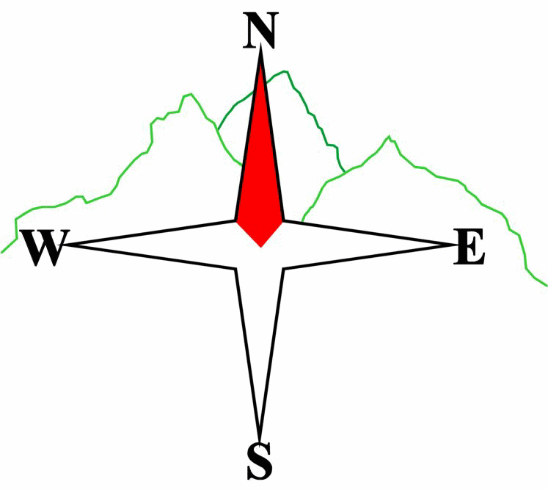
Blairgowrie & District Hillwalking Club

www.bdhc.org.uk
Ballinluig

14/12/2025
O.S. Map No: 52 or 53

Meeting : | Blairgowrie (Wellmeadow): 09:00 |  | Alyth (Square): 08:45
times : | Other: Birnam: 09:20
Transport: | COACH

A Walk – Loch Skiach
Start Kinnaird House on B898 NN 983 498. Take track S uphill and follow to boat house at Loch Skiach. Return to junction at 959 475. Turn NW and follow track down to rejoin the B898. Turn L and follow road NW to Toll House at 968 516. Leave road and go N to old railway bridge. Cross and take A827 to Ballinluig Inn for soup and Christmas pies.

Approx. distance: 14.5 km |  | Total ascent: 460 m |  | Min. walking time: 4¼ hrs

B Walk – As A Walk

C Walk – Mill Dam and Tom na Croiche
Start as A/B walk. Follow track to junction at 977 467. Turn R and follow track NW past Mill Dam. Turn northwards after the lochan and follow track downhill to B898. As with A walk go NW and cross the railway bridge but at Logierait leave the road and take the track along the tree line to access Tom na Croiche and its ruined castle (marked as Meml on the 1:50k map).. Return to road and head for the Ballinluig Inn.

Approx. distance: 8.5 km |  | Total ascent: 300 m |  | Min. walking time: 3½ hrs (@3 kph)

IMPORTANT: YOUR SAFETY IN THE HILLS
The Committee reminds members and guests of the following important points:
- You are responsible for your own safety  - Club officials are not trained mountain leaders  - Are you fit enough to complete your chosen walk in the available time?  - Know where you are going on the walk and follow the route on your map.  - Know how many are in your party and stay together | - Ensure you have enough food plus emergency rations  - Carry a map & compass, survival bag, torch, whistle and small first aid kit. Know how to use them.  - In winter conditions you must carry an ice axe on high level walks (club rule). You are also recommended to carry crampons.  - Learn how to use your equipment.
Club officials will be happy to give advice on any of these points if requested.

The next club walk is on the 04/01/2026 Spittal of Glenshee to Kirkmichael starting at 09:00 (Blairgowrie) and 08:45 (Alyth).
Other information/events: Twix meet at Aviemore on 27-29 December

Please note that the Minimum walking times are based on reasonably fast walkers and assuming good conditions. The times do not include stops or breaks.

In poor weather conditions or if members are not comfortable walking at 4km/hour then alternative or shorter routes should be considered.

Template revision: 2024-12-03

